|  |
| --- |
| Project Lab  **Tailor Web Application**  _____________________    403L-Database Management Systems  Department of Computer System Engineering  University of Engineering and Technology Peshawar    Submitted to: **Engr. Sumayyea Salahuddin**  Submitted by  Group Members  **Muhammad Umar Jan 21pwcse2000**  **Muhammad Saad 21pwcse1997 Hamza 21pwcse1990** |

**Project Title: Tailor Web Application Conceptual Schema of the project:**

**Entities:**

1. Customer
2. Tailor
3. Order
4. Measurement
5. payment

**Relations:**

1. Customer places oder
2. Tailor fulfils
3. Order include measurement
4. Tailer charges payment

**

**RELATIONAL SCHEMA:**

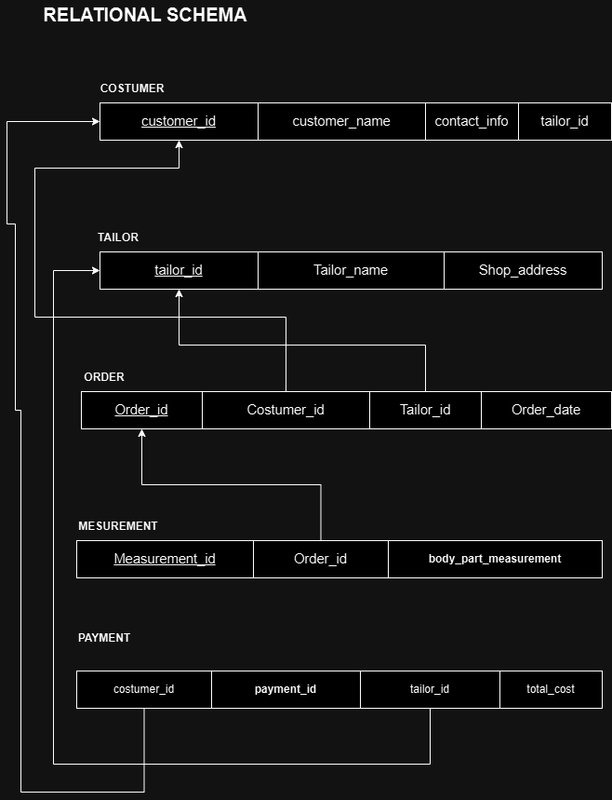

**CONCEPTUAL SCHEMA**

**RELATIONAL SCHEMA WITH NORMALIZATION:**

**COSTUMER**

|  |  |  |  |  |
| --- | --- | --- | --- | --- |
| **customer_id** | **customer_name** | **contact_info** | **tailor_id** | **No_of_orders** |
| 10 | Saad | 03353578797 | 1507 | 2 |
| 11 | Umar jan | 03356868797 | 1508 | 1 |
| 12 | hamza | 03352637654 | 1509 | 3 |

**TAILOR**

|  |  |  |  |
| --- | --- | --- | --- |
| **tailor_id** | **Tailor_name** | **Shop_address** | **Cost_per_cloth** |
| 1507 | Umar | Arbab road | 1500 |
| 1508 | Shiekh | Tahkal | 1500 |
| 1509 | khan | Hayatabad | 1300 |

**ORDER**

|  |  |  |  |
| --- | --- | --- | --- |
| **Order_id** | **Costumer_id** | **Tailor_id** | **Order_date** |
| 27 | 10 | 1507 | 2/7/2023 |
| 29 | 11 | 1508 | 5/6/2024 |
| 37 | 12 | 1509 | 7/1/2024 |

**MESUREMENT**

|  |  |  |
| --- | --- | --- |
| **Measurement_id** | **Order_id** | **Body_part_measurement** |
| 1502 | 27 | 12.4 |
| 1503 | 29 | 32 |
| 1504 | 37 | 23 |

**PAYMENT**

|  |  |  |  |
| --- | --- | --- | --- |
| **Costumer_id** | **Payment_id** | **Tailor_id** | **Total_cost**  **(no_of_orders*tailor’s cost)** |
| 10 | 124 | 1507 | 3000 |
| 11 | 267 | 1508 | 1500 |
| 12 | 564 | 1509 | 4500 |